Study Project – Phase 2 Document
Design and Proof of Concept

Course Title: Study Project
Project Title: Web Based Productivity Toolkit
Group No: 129 (Code Phoenix)
Student Name(s): Muhammad Mohid Alam, Sharad Bhamidipati, Anurag Suman, Shayma Arif
Student ID(s): 2023EBCS161, 2023EBCS373, 2023EBCS082, 2023EBCS506
Project Advisor / Supervisor: Dhruvika Chauhan
Date of Submission: 15/02/2026

1. Introduction
1.1 Purpose of Phase 2
The purpose of Phase 2 is to translate the problem identified in Phase 1 into a concrete and structured system design. This phase focuses on defining detailed system requirements, designing the architecture, and preparing a Proof of Concept. The goal is to demonstrate that the proposed productivity toolkit is technically feasible and logically structured for full implementation in the next phase.
1.2 Scope of Phase 2
Phase 2 includes the following:
- High level system architecture design
- Detailed functional and non-functional requirements
- Database schema design and data flow explanation
- Technology stack selection and justification
- Proof of Concept Video.

2. System Overview
2.1 Product Perspective
The system is a standalone web application designed for students and professionals. It integrates task management, habit tracking, and focus sessions into a single platform. Users interact with the system through a web browser. The front-end communicates with the backend server, which processes logic and interacts with the database. External AI APIs are used for intelligent task scheduling and sorting.
The deployment environment is web based, allowing access through desktop or mobile browsers.
2.2 Major System Functions
The system provides the following major functions:
- User registration and authentication
- Dashboard overview of productivity data
Task Management:
- Task creation, editing, deletion, sorting and marking completion
- Support for subtasks
- Intelligent NLP to extract deadline information and importance from task text
- AI based task scheduling suggestions
- Eisenhower matrix view
Habit Tracking:
- Habit creation with recurring scheduling (hourly, daily, weekly) along with editing and deletion
- Setting inactive hours or skipped days for hourly and daily habits
- Marking Habit instance as complete or skipped
Focus Sessions:
- Pomodoro based focus session management
- Linking tasks and habits to focus sessions

2.3 User Classes and Characteristics
End Users: Students and professionals who want to manage tasks, habits, and focus sessions.
Administrators: System maintainers responsible for monitoring system performance and managing data.
External APIs: AI services used for generating task scheduling or sorting.

3. Functional Requirements
FR1: The system shall allow users to register and log in securely.
FR2: The system shall allow users to create, update, delete, and complete tasks.
FR3: The system shall support subtasks under a main task.
FR4: The system allows users to filter tasks.
FR5: The system shows show tasks in an Eisenberg matrix view.
FR6: The system shall allow users to create recurring habits with defined intervals.
FR7: The system shall generate habit occurrences based on defined schedules.
FR8: The system shall allow users to create focus sessions with custom break length and focus periods.
FR9: The system shall allow tasks and habits to be linked to focus sessions.
FR10: The system shall allow users to start, pause, and end focus sessions and mark tasks/habit occurrences as complete within them.
FR11: The system shall provide AI based task scheduling suggestions.
FR12: The system shall display a dashboard with widgets from each sub app.

4. Non Functional Requirements
4.1 Performance Requirements
The system should respond to user actions within a few seconds under normal load. It should handle multiple concurrent users without significant delay.
4.2 Security Requirements
User authentication must be implemented using secure password storage and session management. Sensitive user data must be protected and hashed and not exposed publicly.
4.3 Usability Requirements
The interface must be simple, clear, and easy to navigate. The design should follow responsive web design principles to support different screen sizes.
4.4 Scalability and Maintainability
The system should follow a modular structure to allow future feature expansion. Code should be organized clearly to simplify maintenance and updates. There should be a clear separation of concerns between various sub applications like task management, habit tracking and focus sessions allowing for better maintenance and future expansion with more sub applications.

5. System Architecture and Design
5.1 System Architecture Diagram
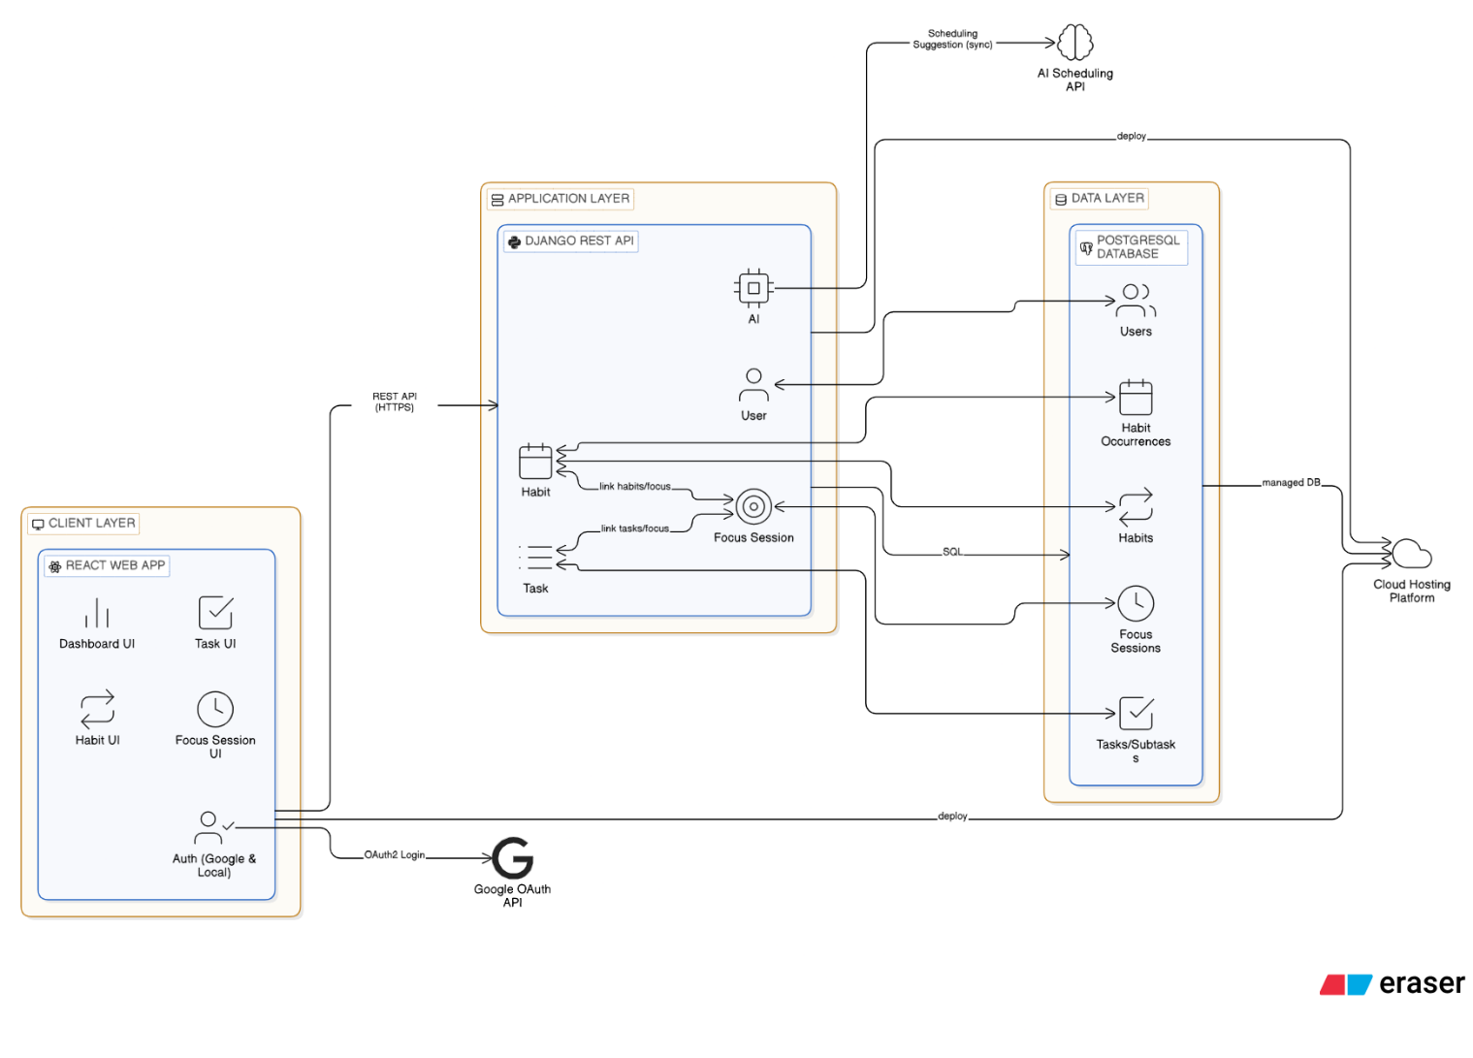
The system follows a three-tier architecture:
Client Layer: React based frontend which handles the user interface and user interactions.
Application Layer: Django backend handles business logic, authentication, and API endpoints.
Data Layer: PostgreSQL database storing users, tasks, habits, and session data.
External AI APIs are connected to the backend for intelligent scheduling suggestions.
5.2 Module wise Design
User Module:
Handles user registration, secure login, logout, and profile management. It manages authentication, password encryption, and session handling. This module ensures that only authorized users can access their personal data. It also supports profile updates and basic account settings management.
Task Module:
Manages full CRUD functionality for tasks and subtasks. It allows users to create tasks with deadlines, priorities, and descriptions. Subtasks are supported using a parent-child relationship structure. The module handles task completion tracking, deadline monitoring, and task organization. It also prepares task data for AI-based scheduling suggestions.
Habit Module:
Handles the creation and management of recurring habits. Users can define habit type (hourly, daily, weekly, monthly) and scheduling rules. The module generates habit occurrences automatically based on defined intervals. It tracks completion status, maintains streak data, and provides progress feedback for consistency monitoring.
Focus Session Module:
Manages pomodoro-based focus sessions. It allows users to start, pause, and end sessions. Tasks and habit occurrences can be linked to a session for structured work. The module tracks session duration, logs productivity data, and contributes to dashboard analytics.
5.3 Data Flow Design
Users input tasks and habits through the frontend interface. The frontend sends structured requests to the backend API using RESTful communication. The backend processes the data, applies business logic, and stores the information in the SQL database. When users request stored data, the backend retrieves it from the database and returns it to the frontend for structured display.
In addition to standard input fields, the system supports natural language task entry. When a user enters a task in free text form, Natural Language Processing (NLP) techniques are applied to extract key attributes such as deadlines, priority level, and importance indicators. For example, phrases like “submit assignment tomorrow” or “urgent meeting at 5 PM” are analyzed to automatically detect time references and urgency. The NLP component processes the raw text, identifies relevant entities such as dates and priority keywords, and converts them into structured fields before the task is finalized.
Once the task attributes are extracted and structured, the frontend sends the validated data to the backend. The backend verifies the data, applies scheduling rules if needed, and stores the task in the database. For AI scheduling, selected task data is securely forwarded to the external AI API through the backend. The API processes the workload and returns an optimized schedule suggestion, which is then displayed to the user for adjustment and confirmation.

5.4 Database Design
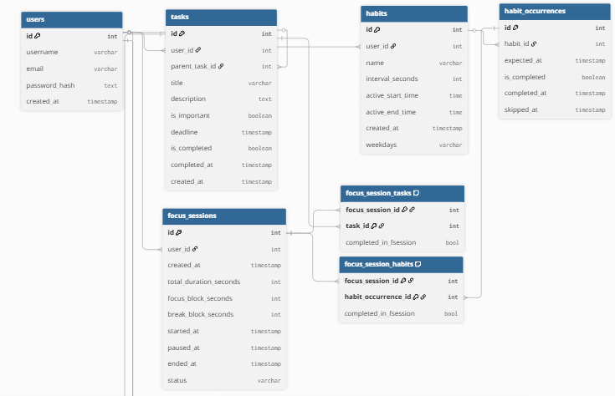
The database includes the following key entities:
- Users
- Tasks
- Habits
- Habit Occurrences
- Focus Sessions
Relationships include one-to-many relationships between users and tasks, users and habits, and tasks and subtasks(stored with parent_id in tasks table). Many to many relationships exist between focus sessions and tasks and focus sessions and habit occurrences.
For habits we store the length of each interval in the interval_seconds attribute. We also store active_start_time and active_end_time and weekdays to ensure occurrences are only populated for active time of the day and the chosen weekdays.
For focus sessions we store the length of focus sessions, the length of break periods and the length of each focus block in seconds. We also store information such as started_at and paused_at to ensure we can resume at will.
For each many to many relationship between focus session and tasks/habit occurrences we also store information like completed_in_session which will help us in the future to possibly extend and build an analytics section.

6. Technology Stack and Justification
Frontend:
React was selected for building a dynamic and responsive user interface. It supports a component based architecture, which allows the application to be divided into reusable and maintainable UI components. This improves code organization and scalability. React also efficiently updates the user interface using a virtual DOM, which enhances performance. Its strong ecosystem and compatibility with responsive web design principles make it suitable for developing a clean and interactive productivity platform that works across different screen sizes.
Backend:
Django was chosen for backend development due to its strong support for rapid development, built in security features, and REST API integration. It provides a structured framework that simplifies authentication, database interaction, and business logic implementation. Django REST Framework enables smooth communication between the frontend and backend through well defined API endpoints. Its emphasis on security helps protect against common vulnerabilities such as SQL injection and cross site scripting.
Database:
PostgreSQL is used for SQL database design because it is reliable, scalable, and well suited for relational data modeling. It supports advanced indexing, data integrity constraints, and efficient query optimization. PostgreSQL ensures structured storage of users, tasks, habits, and session data while maintaining strong consistency and performance under increasing data loads.
Other Tools:
Git is used for version control to manage source code changes and support collaborative development. AI APIs are integrated for intelligent task scheduling and natural language processing. Practical hosting solutions, such as cloud based platforms, will be used to deploy the application for testing and demonstration, ensuring real world accessibility and scalability.

7. Proof of Concept
Proof of Concept Video: https://www.youtube.com/watch?v=en9wWjjlVaA
7.1 PoC Description
The Proof of Concept (PoC) demonstrates a barebones implementation of the proposed system to validate technical feasibility and core functionality. Rather than presenting the full-scale architecture, the PoC focuses on implementing essential features in a simplified environment to confirm that the core idea works in practice.
The PoC application is built using vanilla JavaScript and runs entirely within the browser. All logic, state management, and data storage operate on the client side, using browser-based storage mechanisms. No backend server or external database is integrated at this stage.
The PoC demonstrates three primary modules in their most minimal form:
- Basic Task Management – Users can create and manage simple tasks.
- Habit Tracker – Tracks daily habit occurrences limited to a one-week view.
- Pomodoro Timer – Accepts only focus duration and break duration as inputs. Each completed focus period followed by a break is counted as a single focus session. It does not calculate total accumulated focus time beyond these cycles.
The demonstration video briefly walks through the simplified system architecture and a conceptual database schema to illustrate how the final production system will be structured, even though the PoC itself does not implement the full backend architecture.

7.2 PoC Demonstration Details
The PoC confirms the technical feasibility of the core idea while clearly distinguishing between the prototype and the final system.
The current implementation intentionally excludes several advanced features that are planned for the complete version, including:
- User authentication and account management
- Subtasks within tasks
- Task deadlines with specific time values
- NLP-based deadline and importance extraction
- AI-powered scheduling view
- Eisenhower Matrix task categorization view
- Advanced task filtering mechanisms
- Support for hourly habits with inactive hours
- Weekly habits with configurable inactive days for daily habits
- Expanded habit occurrence tracking beyond one week and in the past.
- Linking focus sessions to specific tasks and habit occurrences to record completion data
In the final implementation, focus sessions will be connected to tasks and habits, allowing session-based tracking of productivity data and persistent storage in the database.

8. Testing and Validation Strategy
Unit testing is performed on backend components to ensure the correctness of core business logic, particularly for task management, habit scheduling, and focus session handling. Individual functions and API endpoints are tested to verify that CRUD operations, recurrence generation, and data validation behave as expected. This helps detect logical errors early in the development process.
Integration testing is conducted to validate communication between the frontend and backend through REST APIs. It ensures that data submitted from the React interface is correctly processed by the Django backend and accurately stored and retrieved from the SQL database. API responses, authentication flows, and error handling mechanisms are also verified during this phase.
Manual testing is performed to evaluate overall usability, navigation flow, and feature consistency. User interactions such as task creation, habit tracking, and session management are tested under different scenarios to confirm system reliability. This combined testing strategy ensures functional accuracy, system stability, and readiness for further development in the next phase.

9. Risks, Challenges, and Mitigation
Identified Risks & Challenges:
- Complexity of implementing the NLP logic to figure out Task Importance and deadline from text.
- Complexity of recurring habit logic and populating habit occurrences.
- Complexity in implementing nested subtasks and adding limitations in place to prevent subtasks from breaking the restrictions in place (e.g. the deadline should not cross the deadline of the parent task).
- Integration with external AI APIs, access to those APIs is limited.
- Time constraints and semester deadlines
Mitigation Strategies:
- Implement modular design for easier debugging and testing for each feature.
- Use controlled API calls and fallback logic and using mock AI responses if external API is unavailable.
- Conducting regular testing and feedback to detect issues early and reduce integration complexity.
- Follow a structured development timeline with weekly team meetups.

10. Phase 2 Outcomes and Readiness for Phase 3
Phase 2 has successfully established a clear and structured foundation for the project by defining the overall system architecture, detailed functional and non-functional requirements, and a well-structured SQL database design. The relationships between core entities such as users, tasks, habits, focus sessions, and related components have been carefully modeled to ensure scalability and maintainability.
A working Proof of Concept video validates the feasibility of the proposed solution. The PoC demonstrates that the frontend and backend integration can operate effectively, API communication is functional, and database operations will perform as intended. It also confirms that the architectural decisions such as modular separation of components and REST-based communication are technically sound.
Through this phase, potential implementation risks have been identified and addressed at the design level, reducing uncertainty in subsequent development stages. The project is therefore technically prepared for full-scale implementation, feature enhancement, AI integration refinement, interface optimization, and performance improvements in Phase 3. The groundwork laid in this phase ensures a smooth transition from conceptual design to complete system realization.

11. Supervisor Review and Approval
Advisor Feedback:
Supervisor Comments:
Recommendations:
Signature: ___________________________

Date: _____15/02/2026______

